
East Rand Convention 2025
AA Pre- registration Form
Amount R130.00
Name | Group | City/ Province | Name to appear on name tag | Amount paid
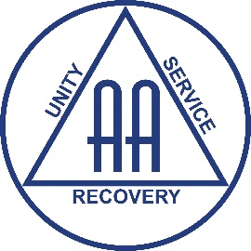
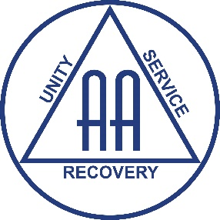
Banking Details:
Name: ALCOHOLICS ANONYMOUS EAST RAND BANK: NEDBANK LIMITED
BRANCH: PRINCESS PARK
ACCOUNT NUMBER: 1903 342 503 BRANCH CODE: 186 242
ACCOUNT TYPE: CURRENT / CHEQUE ACCOUNT
NB: Please use Pre-Reg (Name & Group Name) as reference when paying via EFT.
Please email forms to aaeastrand@gmail.com or contact the Office @ 011 421 1748

East Rand Convention 2025
AL-ANON Pre- registration Form
Amount R130.00

Name | Group | City/ Province | Name to appear on name tag | Amount paid
Banking Details:
Name: ALCOHOLICS ANONYMOUS EAST RAND BANK: NEDBANK LIMITED
BRANCH: PRINCESS PARK
ACCOUNT NUMBER: 1903 342 503 BRANCH CODE: 186 242
ACCOUNT TYPE: CURRENT / CHEQUE ACCOUNT
NB: Please use Pre-Reg (Name & Group Name) as reference when paying via EFT.
Please email forms to aaeastrand@gmail.com or contact the Office @ 011 421 1748

